

Widget Test Pattern for ETM

Version | (2024-06-19)
Date | 2024-06-19
Status | Release
Author | Kornelius Wiebe, Oswald Walz

Table of Contents

Introduction 3
User Interface 6
Synchronize 7
Edit Test Case 8
Update Test Case 8
Ignore Test Case 9
Show Problems 9
Add Module Reference 9
Utilities 9
User guide 9

Introduction
The TestPat widget functionality is described in this document.

TestPat is based on the widget ReqPat, which is used inside DOORS Next (IBM Engineering Requirements Management DOORS Next) as an editor for requirement and test patterns.

Since Jazz environment offers a separate test management application ETM (IBM Engineering Test Management) for handling tests it does make sense to have the same editor inside ETM environment.

TestPat enables the user to edit test patterns in a similar way as known from ReqPat.

Precondition 1: TestPat needs to be started in an ETM project area which is placed in a global configuration context stream. The initial Test Pattern Module must be part of this global configuration.

Precondition 2: TestPad needs an initial mapping module (Initial Test Pattern Module; same as for ReqPat widget) which is placed in the DOORS Next project area.
Caution: You need write access to this module, if you want to add optional Module References – they will be stored in module attribute ‘ReqPat_linking’ of mandatory Initial Test Pattern Module.

Precondition 3: Tested with external application ReqPat 4.3.0. Please take care to use this version.

For further information and understanding of TestPat widget please read the following documents about ReqPat widget, too:

Precondition 4: Add all mandatory ReqPat attributes like ‘ReqPat-ID’ to the ‘Test Case Attributes’ list in ‘Manage Project Properties’.
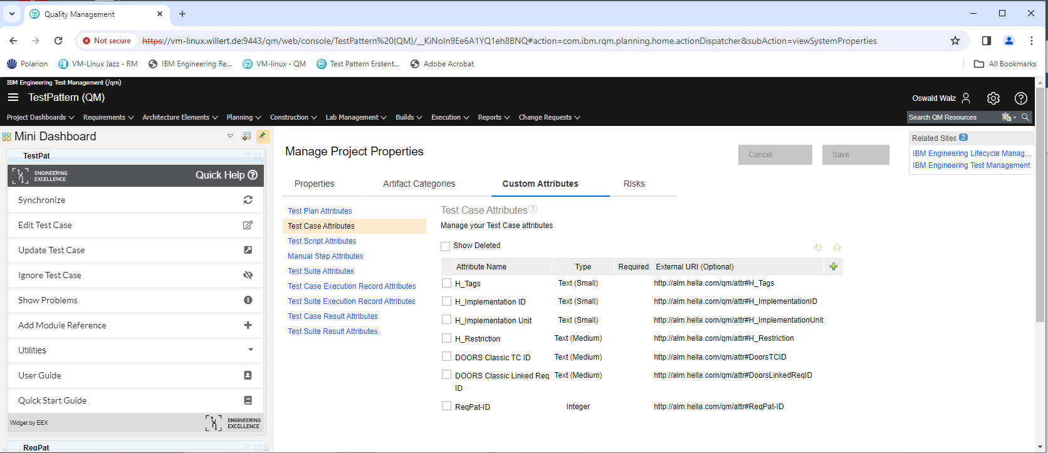

Precondition 5: Add all mandatory ReqPat attributes like ‘ReqPat-ID’ to the Test Pattern Module(s). Make sure that ReqPat widget inside DOORS Next is able to load these files.
If ReqPat is not able to load them then TestPat will not be able to load them, too.

The TestPat widget is performed in following steps:

Step 1: Start the external ReqPat executable ‘ReqPat.exe’.
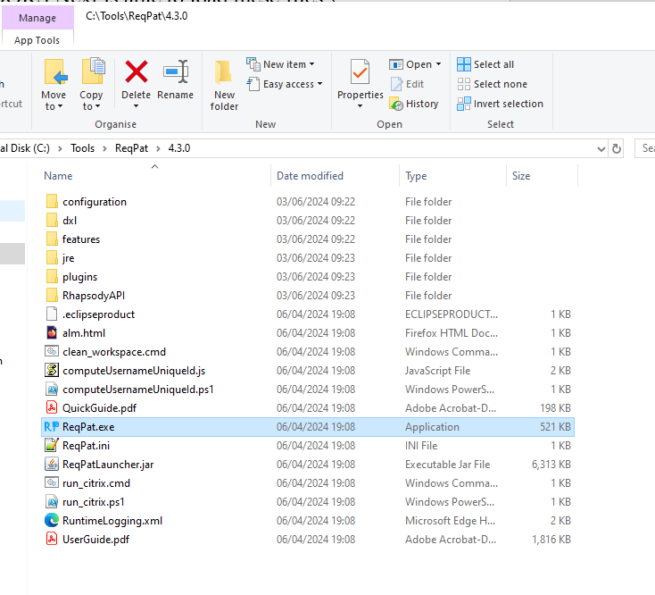
After successful start you should see following icon called ‘RP’ in task bar.
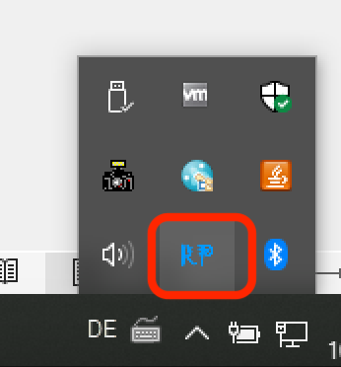
Step 2: Load the initial DOORS Next module with predefined and common test design elements, pre/post conditions, …, which is normally used for using ReqPat widget inside DOORS Next.
Step 3: Switch to one Test Case displayed in the editor.
Step 4: Now you can use TestPat to edit or update the Test Case via the external application ‘ReqPat.exe’ in the same way as ReqPat.

User Interface

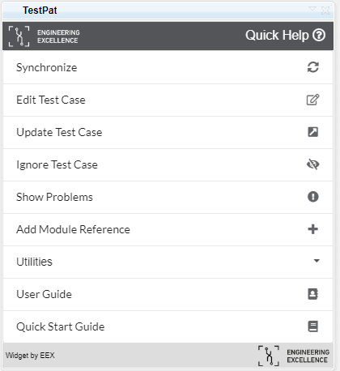

The individual steps can be carried out using the buttons on the UI. If the prerequisite for the step is not met, the button is grayed out.

Clicking on the "Get a quick tutorial" button will display a short description of the widget.

Synchronize
TestPat requires a module that defines the predefined and common test design elements, pre / post conditions and test feature packages which are still located in the DOORS Next project area.
This DOORS Next project area has to be in the same global configuration stream. Otherwise selection dialog will not display any module.
Note: The module itself has to follow the structure and needs of ReqPat widget and application. Please see ReqPat documentation for further information.

In the selection dialog you can select the ReqPat module which shall be synchronized with.
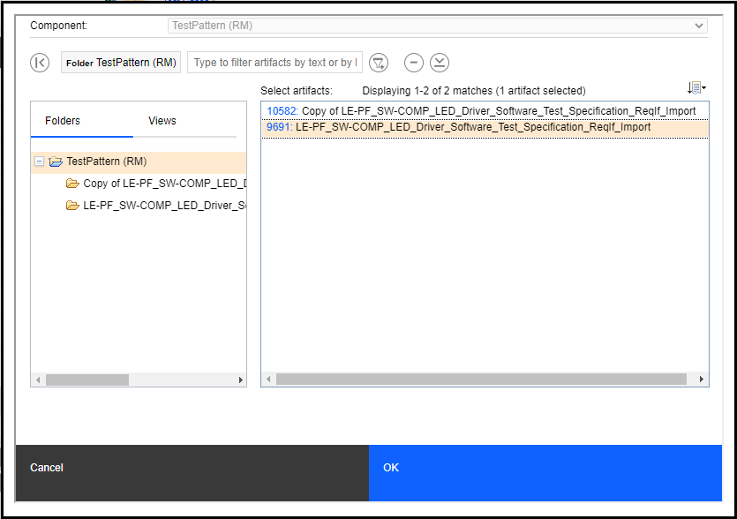

After pressing ‘OK’ the module will by read and converted to a content format which external ReqPat application needs to have.
Futhermore all test cases will be read, converted and added to this ReqPat content.
This content will be sent as one package to the external ReqPat application.

After successful synchronizing external ReqPat application is displaying following information:
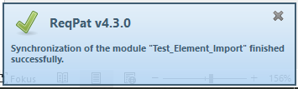
Now you can start editing a Test Case.

Edit Test Case
Precondition: Open a Test Case in the Test Case viewer of ETM.
Note: The content of the Test Case is placed in ‘Test Case Design’.

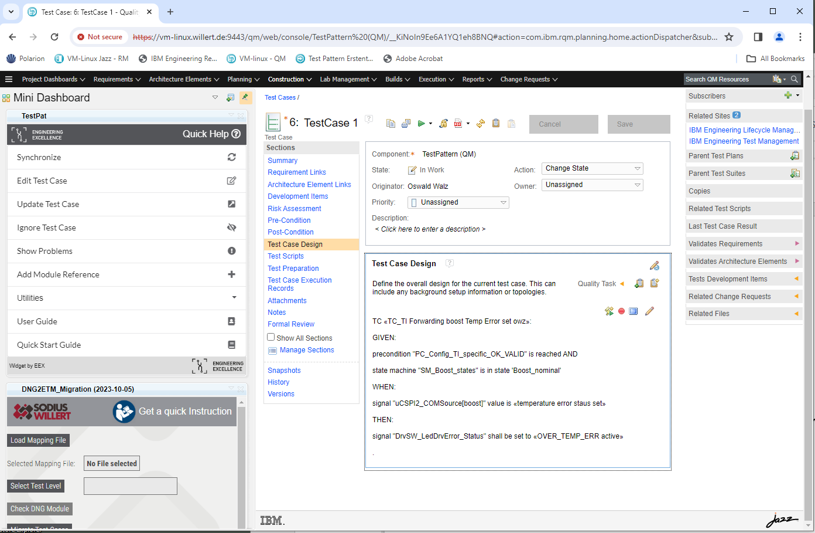

Press ‘Edit Test Case’. The ReqPat editor is displayed.
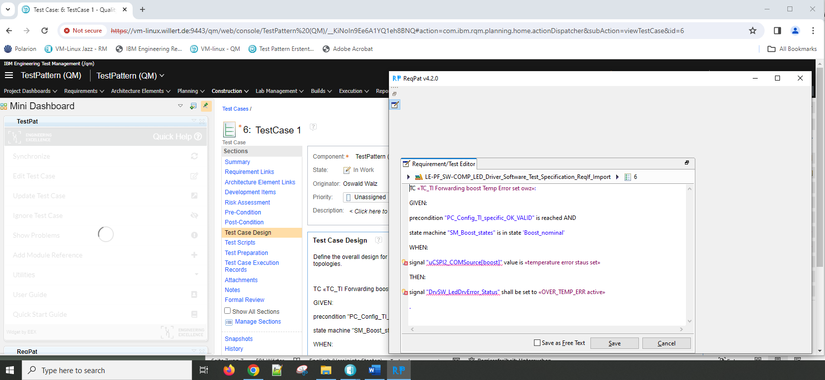

The TestPat editor can be used in the same way as the ReqPat editor. It is the same.
After pressing ‘Save’ the content will be saved in Test Case Design.
Note: If editor is not displayed in front when select ‘RP’ in the task bar!

Update Test Case
The same behavior as in ReqPat widget.

Ignore Test Case
The same behavior as in ReqPat widget.

Show Problems
The same behavior as in ReqPat widget.

Add Module Reference
The same behavior as in ReqPat widget.

Utilities
The same behavior as in ReqPat widget.

User guide
The same behavior as in ReqPat widget till yet.

Quick Start Guide
The same behavior as in ReqPat widget till yet.

